

Contents

Hardware and software requirements 3

Hardware 3

Software 3

System security 3

Virus Protection 3

Password protection 3

Backups 3

Installation guide 4

Program 4

SQL server data file (.BAK file) 4

Step-by-step walkthrough of system 7

Menu 7

Students 8

Tutors 10

Block Bookings 12

Lesson timetable 14

Timetabled lessons 16

External exams 18

Exam entries 20

Student reports 22

Tutor reports 23

Booking reports 24

Payment reports 25

Backup procedures 26

Creating a backup of the SQL server 26

Error handling 29

Further help and support 30

# Hardware and software requirements

Minimum hardware is not the technical minimum, simply the recommended minimum, any less may work but is not advised and would severely hinder performance and likely functionality.

## Hardware

|  |  |  |
| --- | --- | --- |
| Hardware | Min | Recommended |
| Processor | 2GHZ Single Core | 3GHZ Dual Core |
| Hard drive space free | 25GB | 50GB |
| RAM | 4GB | 8GB |
| Resolution | 1366x768 | 1920x1080 |

## Software

|  |  |  |
| --- | --- | --- |
| Software | Min | Recommended |
| Operating system | Windows 7 | Windows 10 |
| .NET Environment | Visual studio 2013 | Visual studio 2015 |
| .NET Framework | .Net Framework 4.0 | .NET Framework 4.5 |
| SQL server management version | SQL server management 2013 | SQL server management 2015 |

## System security

### Virus Protection

* This computer system should be protected by anti-malware software.
* Computer system should be frequently.

### Password protection

* Ensure the system is protected by password.
* Passwords should be of sufficient complexity, at least 8 characters, at least 1 number and has capitals.

### Backups

* Database should be frequently backed up at least once a week.
* For additional information, see: Backup procedures.

# Installation guide

## Program

## SQL server data file (.BAK file)

* Load SQL server management studio

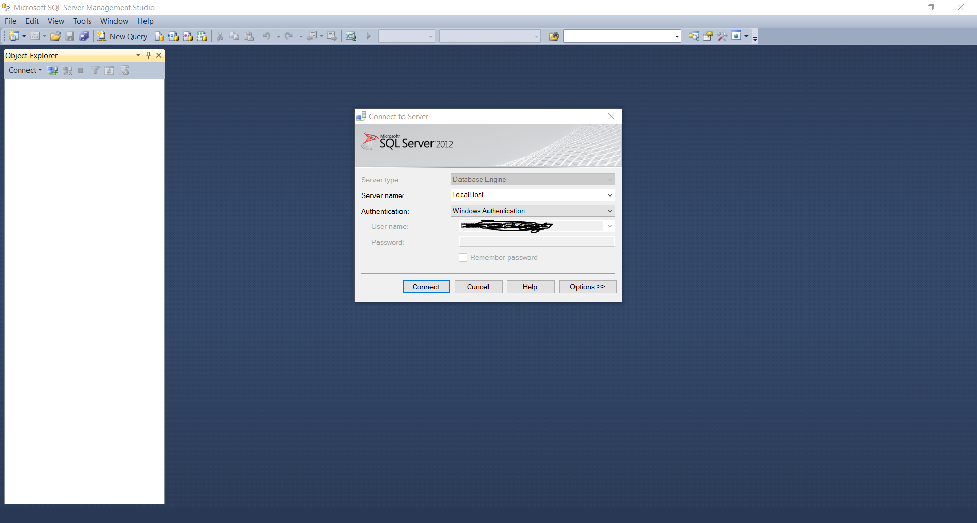

* Click connect
* Right click databases and press “Restore Database…”

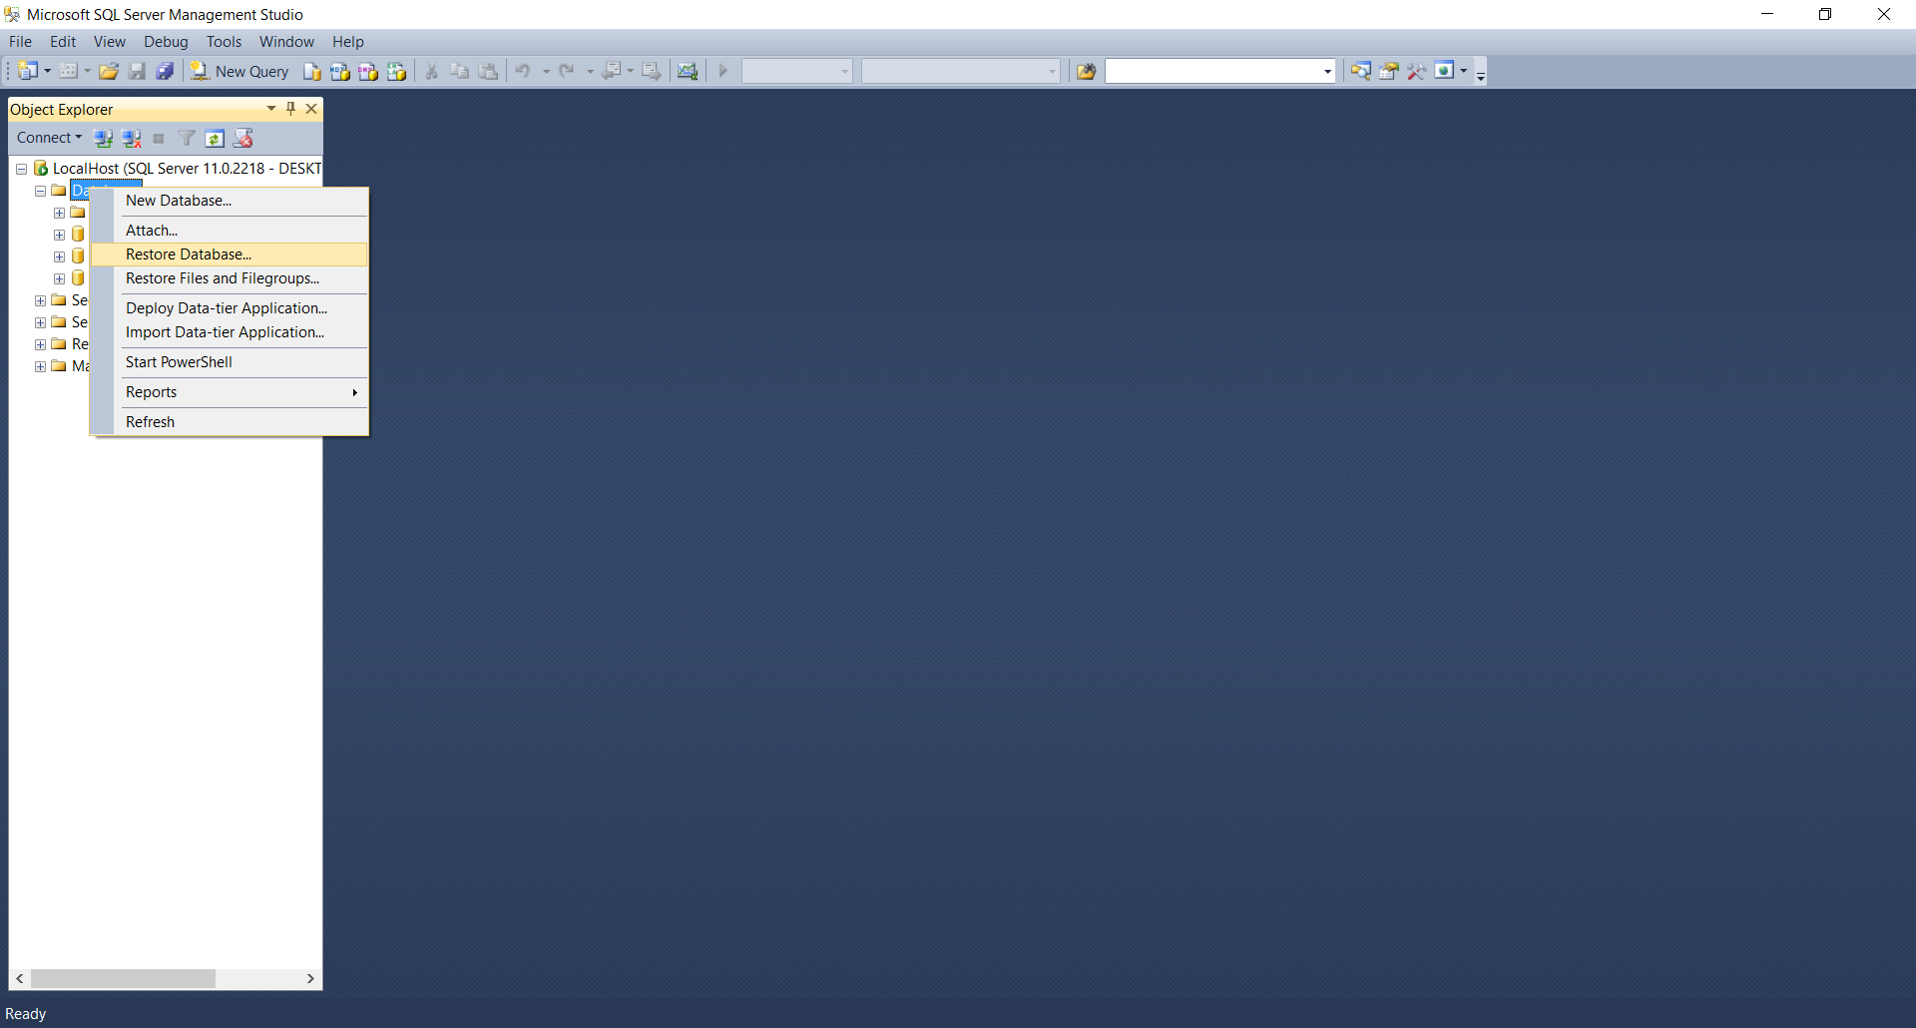

* Click device selection in the source area

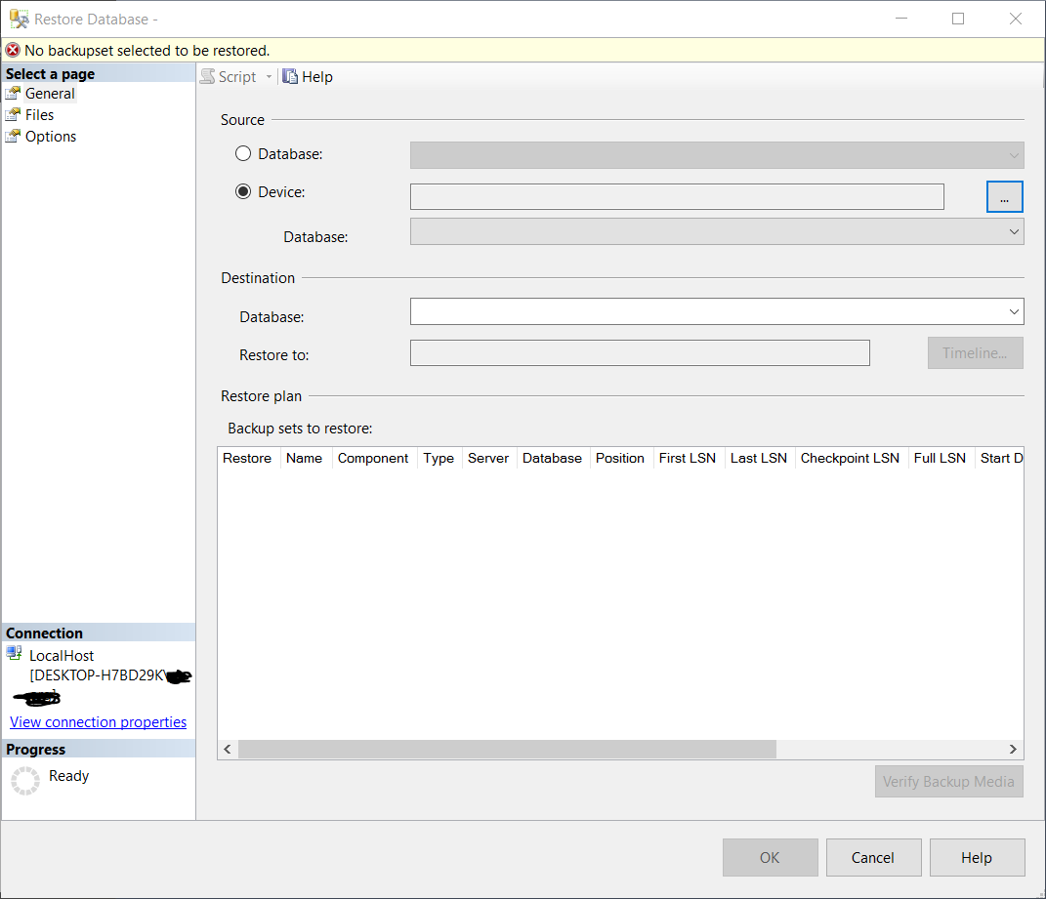

* Then select the three-dotted button to the right of the textbox.

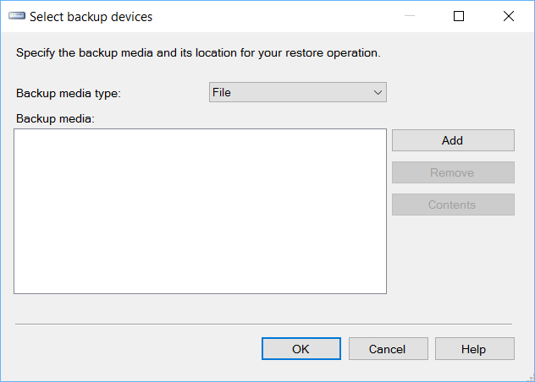

* Click add to open a file explorer.
* Find and select the .BAK file within your system.

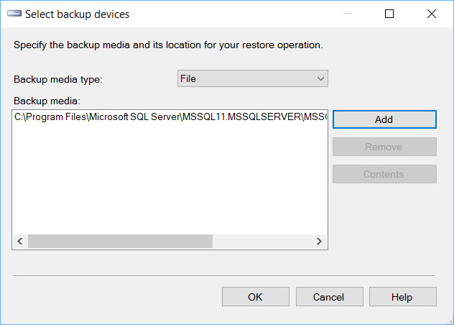

* Click “OK”

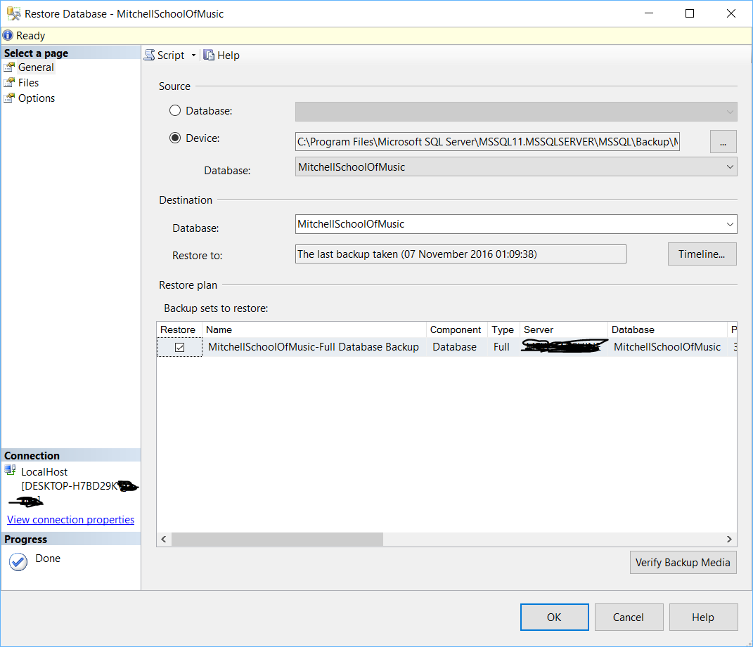

* The .BAK file is now selected, Press “OK” to restore database.

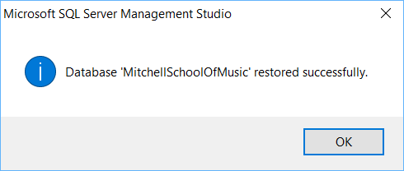

* The application should now be operational and be able to connect to the database.

# Step-by-step walkthrough of system

## Menu

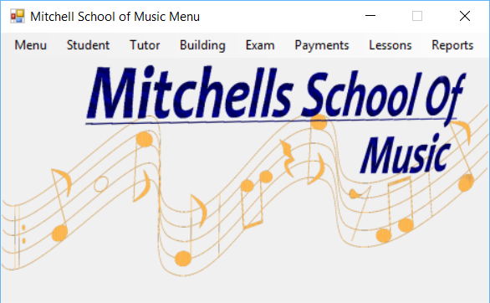

## Students

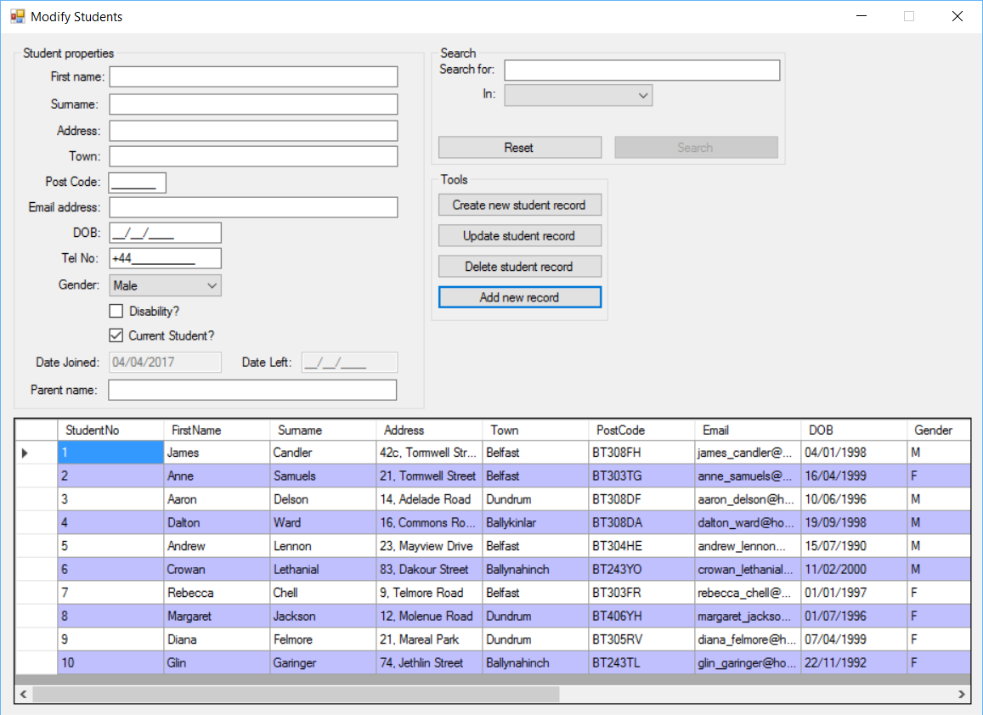

#### Adding students

1. Fill in all necessary fields.
2. Once verified and valid, the entered data will be entered into a class, after which, all information will be ported into a data row of its respective database and finally added to the database, updating the database itself with the new details. If the data entered is invalid, an error provider will appear next to the incorrect fields, instructing the user as to where they went wrong.

#### Deleting students

1. Select a data row to delete in the data grid view.
2. Press the delete button in the tools group box.
3. A prompt will appear, asking if you are sure you wish to delete the selected row.
4. Pressing yes will complete deletion of the selected row.
5. Pressing no will cancel the deletion process.

#### Updating students

1. Select a data row to update from the data grid view.
2. Selecting a data row will auto-fill all fields within the properties section of the form with details from the data row.
3. Modifications can be made to this data as needed.
4. Pressing the update data button in the tools group box will update the selected row with the data entered once it has confirmed it to be valid and added to a class.
5. If invalid, the error provider will appear next to the invalid fields and inform the user where they went wrong.

#### Sorting students

1. Clicking the column by which to sort within the data grid view will sort the database by that field.

#### Searching students

1. The user can type the word, number, date or true/false value for which they wish to search into the search text box.
2. The user should then select the column by which they wish to search using the combo box below the search field which contains each of the columns available to be searched.
3. The user should then press the search button to commence search.
4. The data grid view will then be filtered to match the search criteria.

## Tutors

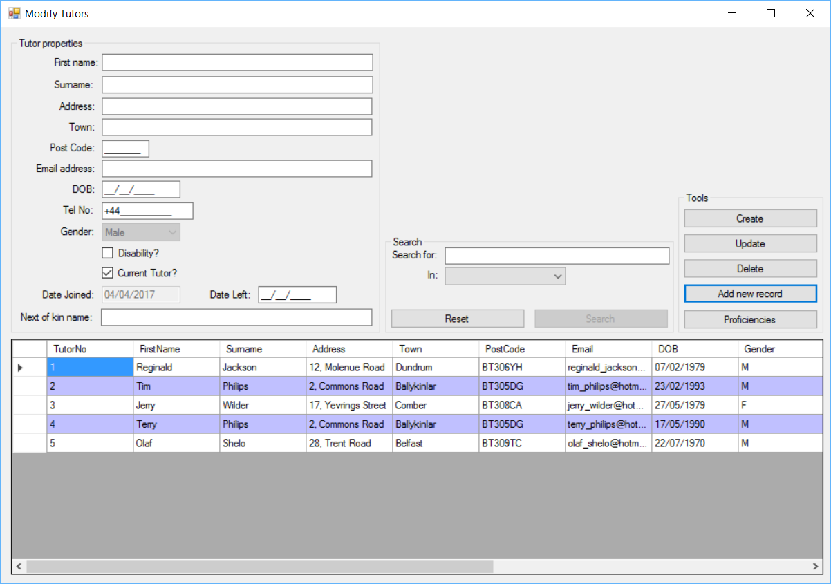

#### Adding tutors

1. Fill in all necessary fields.
2. Once verified and valid, the entered data will be entered into a class, after which, all information will be ported into a data row of its respective database and finally added to the database, updating the database itself with the new details. If the data entered is invalid, an error provider will appear next to the incorrect fields, instructing the user as to where they went wrong.

#### Deleting tutors

1. Select a data row to delete in the data grid view.
2. Press the delete button in the tools group box.
3. A prompt will appear, asking if you are sure you wish to delete the selected row.
4. Pressing yes will complete deletion of the selected row.
5. Pressing no will cancel the deletion process.

#### Updating tutors

1. Select a data row to update from the data grid view.
2. Selecting a data row will auto-fill all fields within the properties section of the form with details from the data row.
3. Modifications can be made to this data as needed.
4. Pressing the update data button in the tools group box will update the selected row with the data entered once it has confirmed it to be valid and added to a class.
5. If invalid, the error provider will appear next to the invalid fields and inform the user where they went wrong.

#### Sorting tutors

1. Clicking the column by which to sort within the data grid view will sort the database by that field.

#### Searching tutors

1. The user can type the word, number, date or true/false value for which they wish to search into the search text box.
2. The user should then select the column by which they wish to search using the combo box below the search field which contains each of the columns available to be searched.
3. The user should then press the search button to commence search.
4. The data grid view will then be filtered to match the search criteria.

## Block Bookings

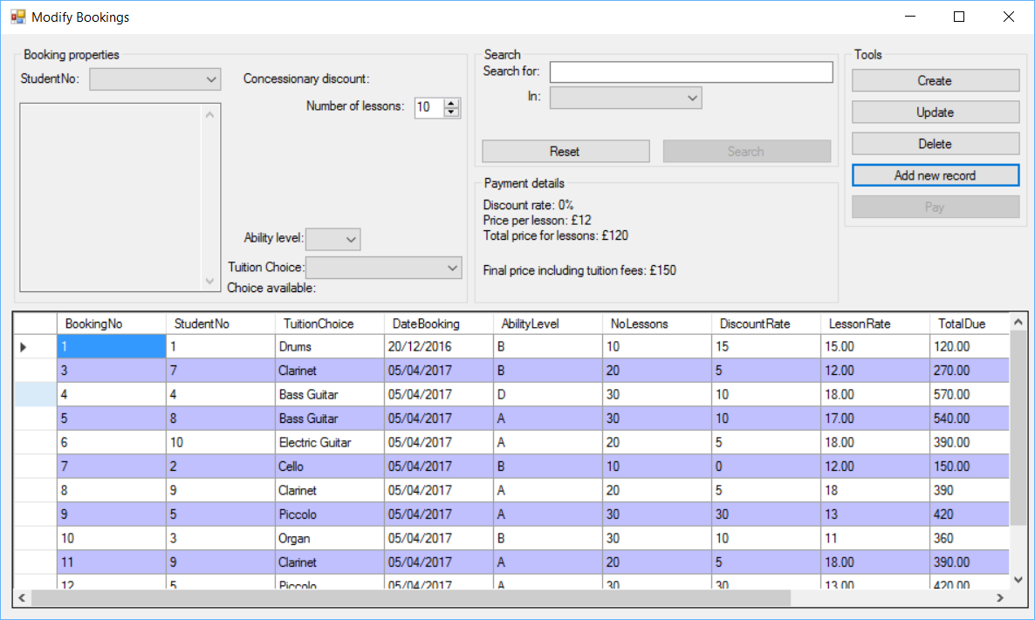

#### Adding Block Booking

1. Fill in all necessary fields.
2. Once verified and valid, the entered data will be entered into a class, after which, all information will be ported into a data row of its respective database and finally added to the database, updating the database itself with the new details. If the data entered is invalid, an error provider will appear next to the incorrect fields, instructing the user as to where they went wrong.

#### Deleting Block Booking

1. Select a data row to delete in the data grid view.
2. Press the delete button in the tools group box.
3. A prompt will appear, asking if you are sure you wish to delete the selected row.
4. Pressing yes will complete deletion of the selected row.
5. Pressing no will cancel the deletion process.

#### Updating Block Booking

1. Select a data row to update from the data grid view.
2. Selecting a data row will auto-fill all fields within the properties section of the form with details from the data row.
3. Modifications can be made to this data as needed.
4. Pressing the update data button in the tools group box will update the selected row with the data entered once it has confirmed it to be valid and added to a class.
5. If invalid, the error provider will appear next to the invalid fields and inform the user where they went wrong.

#### Sorting Block Booking

1. Clicking the column by which to sort within the data grid view will sort the database by that field.

#### Searching Block Booking

1. The user can type the word, number, date or true/false value for which they wish to search into the search text box.
2. The user should then select the column by which they wish to search using the combo box below the search field which contains each of the columns available to be searched.
3. The user should then press the search button to commence search.
4. The data grid view will then be filtered to match the search criteria.

#### Paying for Block Booking

1. Select a created data row that has not yet been paid for.
2. Click the pay button in the tools group box.
3. A payment window will open. 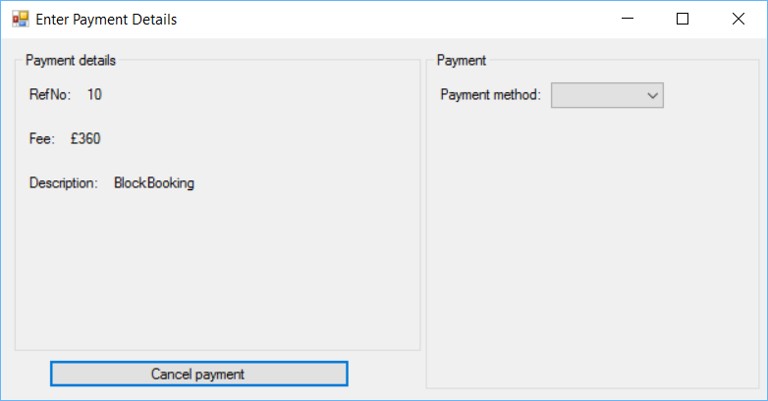
4. Select the payment method with the combo box on the right. Different payment methods will require the entry of different fields.

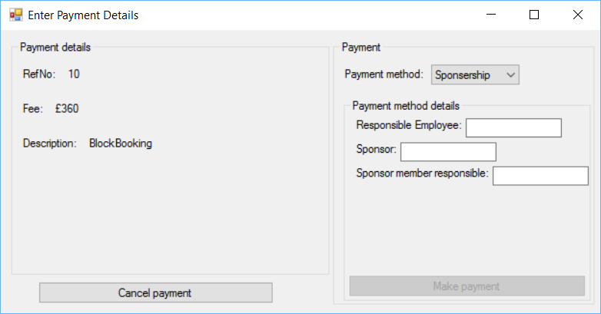

1. Enter required data into fields.
2. The make payment button should now be clickable, clicking on it reveals a message box informing the user that the payment was successful if all data was entered correctly. A payment record is saved to the payment table and clicking okay on the message box will send the user back to the relevant form from which the payment was requested.

Lesson timetable

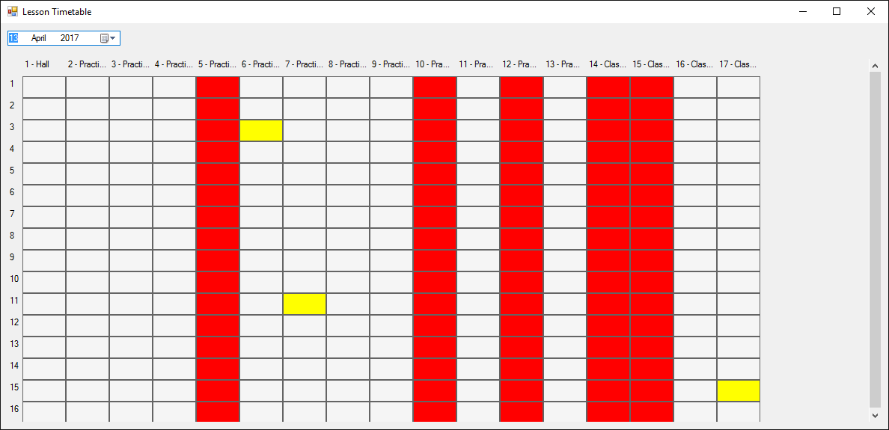

#### Searching for lessons on a day

1. Select the date time picker.
2. Select a date from the date time picker.
3. The grid beneath the date time picker will now be rearranged based on the selected day.
4. Nothing will happen if the selected day was a weekend as the school is not available on those days.
5. Only half the usual periods will appear if a Friday is selected as that day is a half day for the school. 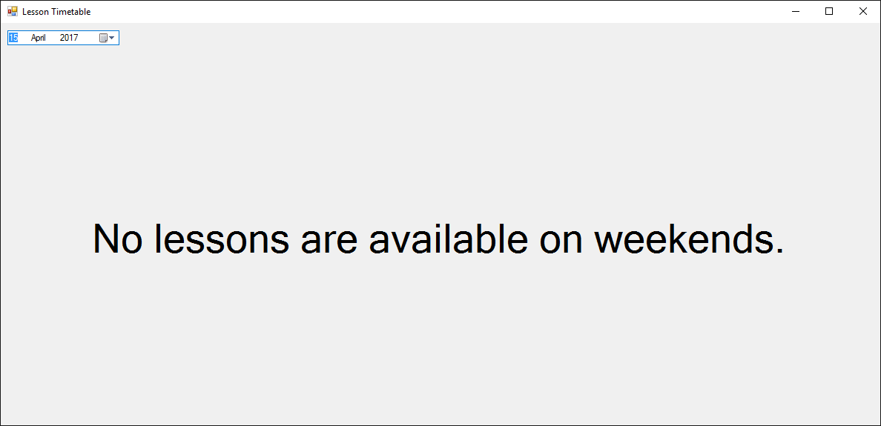

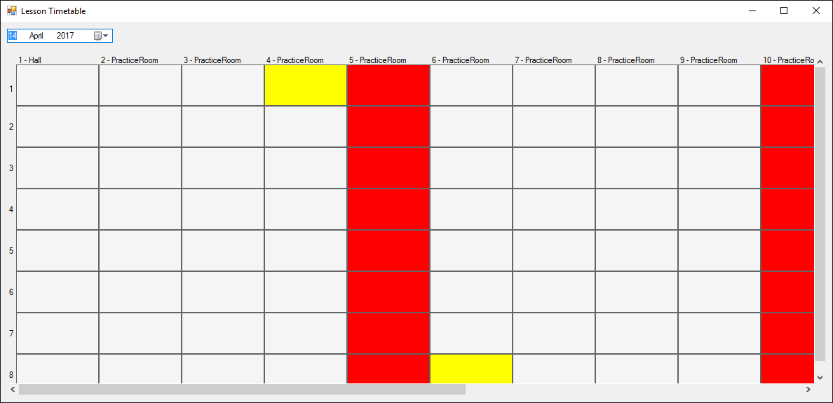

#### Finding information about a day

1. If a cell is yellow, a lesson is planned for that day.
2. If a cell is red, that room is not available for classes for whatever reason.
3. If a cell is white, that room at that time of day is open for booking.
4. Hovering the mouse cursor over a cell will reveal additional details about it, such as the room and period of the day. As well as any lessons that may be taking place within that cell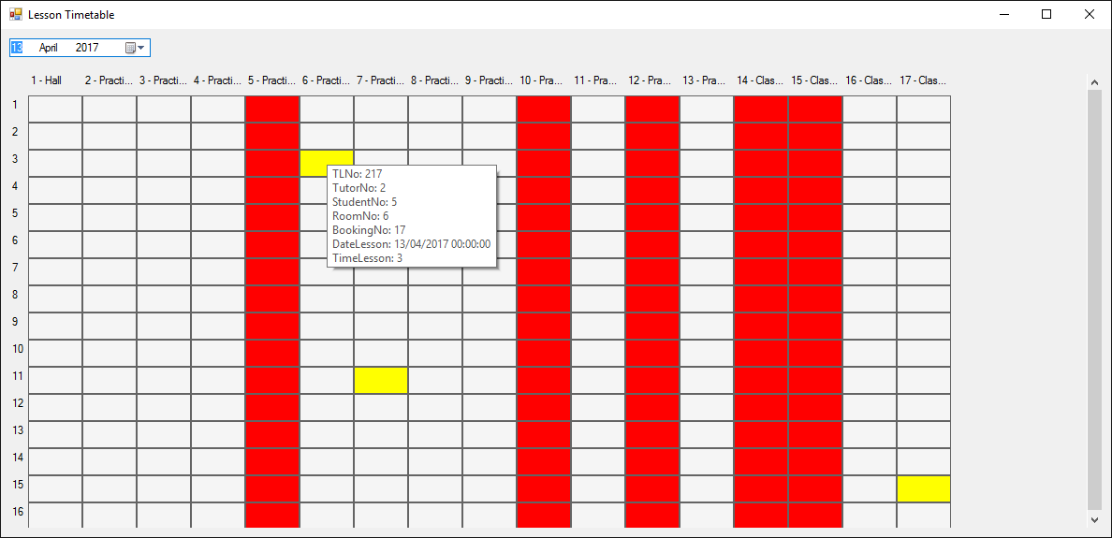

#### Booking lessons for a day

1. Clicking on a white cell will offer the user a transfer to the timetabling for lessons form.
2. A message box will appear offering if the user would like to transfer to the form where lessons can be booked.
3. If the user says no, the message box will disappear and the form will return to normal.
4. If the user says yes, they will be transferred to the form where lessons can be booked with the day and period of day pre-selected for them. (See Modify Lessons).

## Timetabled lessons

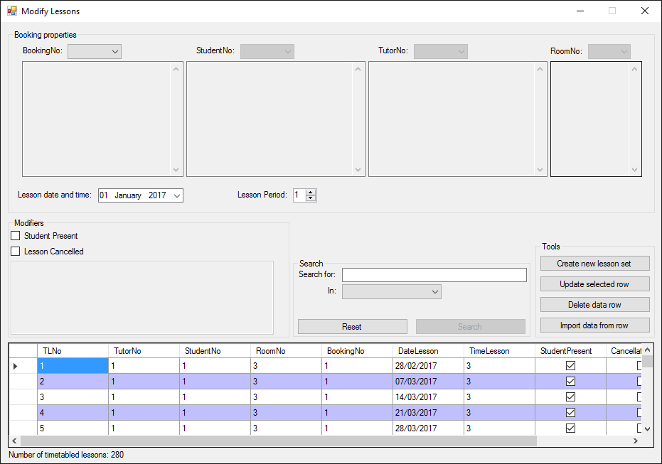

#### Adding Lessons

1. Selecting the booking will auto filter and select some other options as somethings would not be applicable to certain block bookings.
2. Fill in all necessary fields.
3. Once verified and valid, the entered data will be entered into a class, after which, all information will be ported into a data row of its respective database and finally added to the database, updating the database itself with the new details. If the data entered is invalid, an error provider will appear next to the incorrect fields, instructing the user as to where they went wrong.
4. The database will be searched and checked to ensure that the lessons generated do not conflict with other lessons before lessons are written to the database.
5. The number of lessons created is equal to the number of lessons requested within the block booking.

#### Deleting Lessons

1. Select a data row to delete in the data grid view.
2. Press the delete button in the tools group box.
3. A prompt will appear, asking if you are sure you wish to delete the selected row.
4. Pressing yes will complete deletion of the selected row.
5. Pressing no will cancel the deletion process.

#### Updating Lessons

1. Select a data row to update from the data grid view.
2. Selecting a data row will auto-fill all fields within the properties section of the form with details from the data row.
3. Modifications can be made to this data as needed.
4. Pressing the update data button in the tools group box will update the selected row with the data entered once it has confirmed it to be valid and added to a class.
5. If invalid, the error provider will appear next to the invalid fields and inform the user where they went wrong.

#### Sorting Lessons

1. Clicking the column by which to sort within the data grid view will sort the database by that field.

#### Searching Lessons

1. The user can type the word, number, date or true/false value for which they wish to search into the search text box.
2. The user should then select the column by which they wish to search using the combo box below the search field which contains each of the columns available to be searched.
3. The user should then press the search button to commence search.
4. The data grid view will then be filtered to match the search criteria.

## External exams

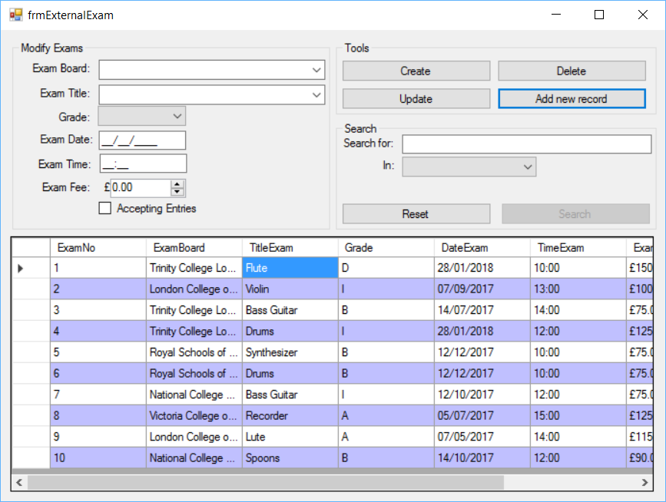

#### Adding exams

1. Fill in all necessary fields.
2. Once verified and valid, the entered data will be entered into a class, after which, all information will be ported into a data row of its respective database and finally added to the database, updating the database itself with the new details. If the data entered is invalid, an error provider will appear next to the incorrect fields, instructing the user as to where they went wrong.

#### Deleting exams

1. Select a data row to delete in the data grid view.
2. Press the delete button in the tools group box.
3. A prompt will appear, asking if you are sure you wish to delete the selected row.
4. Pressing yes will complete deletion of the selected row.
5. Pressing no will cancel the deletion process.

#### Updating exams

1. Select a data row to update from the data grid view.
2. Selecting a data row will auto-fill all fields within the properties section of the form with details from the data row.
3. Modifications can be made to this data as needed.
4. Pressing the update data button in the tools group box will update the selected row with the data entered once it has confirmed it to be valid and added to a class.
5. If invalid, the error provider will appear next to the invalid fields and inform the user where they went wrong.

#### Sorting exams

1. Clicking the column by which to sort within the data grid view will sort the database by that field.

#### Searching exams

1. The user can type the word, number, date or true/false value for which they wish to search into the search text box.
2. The user should then select the column by which they wish to search using the combo box below the search field which contains each of the columns available to be searched.
3. The user should then press the search button to commence search.

The data grid view will then be filtered to match the search criteria.

## Exam entries

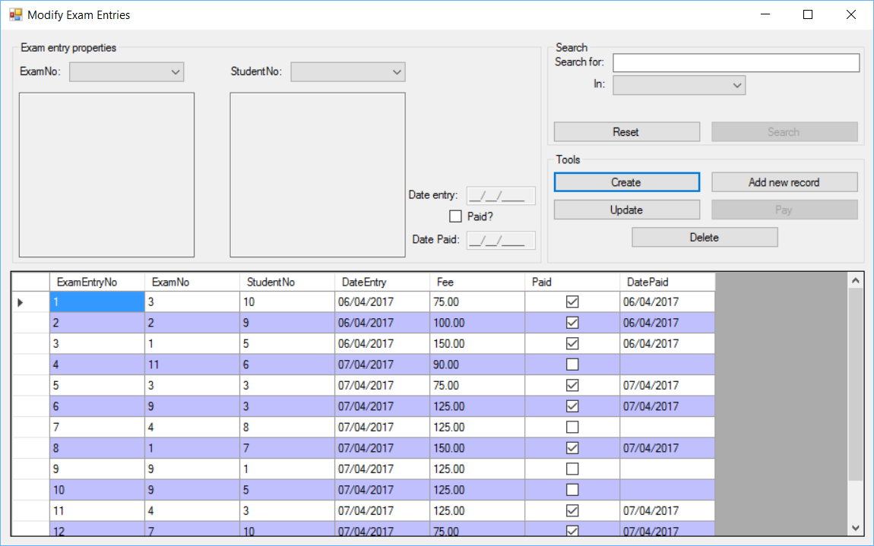

#### Adding exam entries

1. Fill in all necessary fields.
2. Once verified and valid, the entered data will be entered into a class, after which, all information will be ported into a data row of its respective database and finally added to the database, updating the database itself with the new details. If the data entered is invalid, an error provider will appear next to the incorrect fields, instructing the user as to where they went wrong.

#### Deleting exam entries

1. Select a data row to delete in the data grid view.
2. Press the delete button in the tools group box.
3. A prompt will appear, asking if you are sure you wish to delete the selected row.
4. Pressing yes will complete deletion of the selected row.
5. Pressing no will cancel the deletion process.

#### Updating exam entries

1. Select a data row to update from the data grid view.
2. Selecting a data row will auto-fill all fields within the properties section of the form with details from the data row.
3. Modifications can be made to this data as needed.
4. Pressing the update data button in the tools group box will update the selected row with the data entered once it has confirmed it to be valid and added to a class.
5. If invalid, the error provider will appear next to the invalid fields and inform the user where they went wrong.

#### Sorting exam entries

1. Clicking the column by which to sort within the data grid view will sort the database by that field.

#### Searching exam entries

1. The user can type the word, number, date or true/false value for which they wish to search into the search text box.
2. The user should then select the column by which they wish to search using the combo box below the search field which contains each of the columns available to be searched.
3. The user should then press the search button to commence search.
4. The data grid view will then be filtered to match the search criteria.

#### Paying for Block Booking

1. Select a created data row that has not yet been paid for.
2. Click the pay button in the tools group box.
3. A payment window will open. 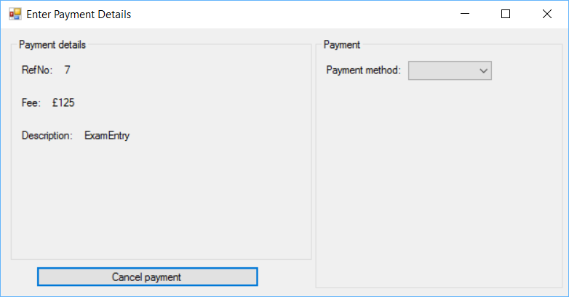
4. Select the payment method with the combo box on the right. Different payment methods will require the entry of different fields.

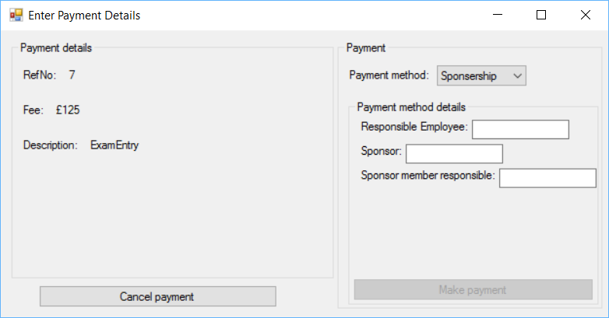

1. Enter required data into fields.
2. The make payment button should now be clickable, clicking on it reveals a message box informing the user that the payment was successful if all data was entered correctly. A payment record is saved to the payment table and clicking okay on the message box will send the user back to the relevant form from which the payment was requested.

## Rooms

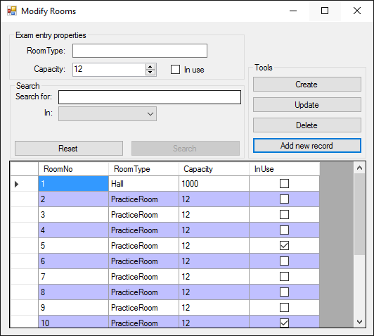

#### Adding rooms

1. Fill in all necessary fields.
2. Once verified and valid, the entered data will be entered into a class, after which, all information will be ported into a data row of its respective database and finally added to the database, updating the database itself with the new details. If the data entered is invalid, an error provider will appear next to the incorrect fields, instructing the user as to where they went wrong.

#### Deleting rooms

1. Select a data row to delete in the data grid view.
2. Press the delete button in the tools group box.
3. A prompt will appear, asking if you are sure you wish to delete the selected row.
4. Pressing yes will complete deletion of the selected row.
5. Pressing no will cancel the deletion process.

#### Updating rooms

1. Select a data row to update from the data grid view.
2. Selecting a data row will auto-fill all fields within the properties section of the form with details from the data row.
3. Modifications can be made to this data as needed.
4. Pressing the update data button in the tools group box will update the selected row with the data entered once it has confirmed it to be valid and added to a class.
5. If invalid, the error provider will appear next to the invalid fields and inform the user where they went wrong.

#### Sorting rooms

1. Clicking the column by which to sort within the data grid view will sort the database by that field.

#### Searching rooms

1. The user can type the word, number, date or true/false value for which they wish to search into the search text box.
2. The user should then select the column by which they wish to search using the combo box below the search field which contains each of the columns available to be searched.
3. The user should then press the search button to commence search.
4. The data grid view will then be filtered to match the search criteria.

## Past payments

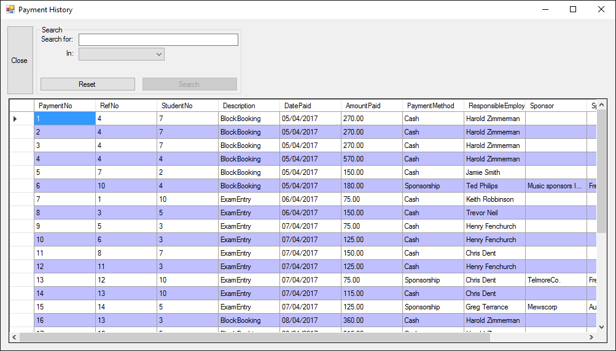

#### Searching past payments

1. The user can type the word, number, date or true/false value for which they wish to search into the search text box.
2. The user should then select the column by which they wish to search using the combo box below the search field which contains each of the columns available to be searched.
3. The user should then press the search button to commence search.
4. The data grid view will then be filtered to match the search criteria.

#### Sorting past payments

1. Clicking the column by which to sort within the data grid view will sort the database by that field.

## Student reports

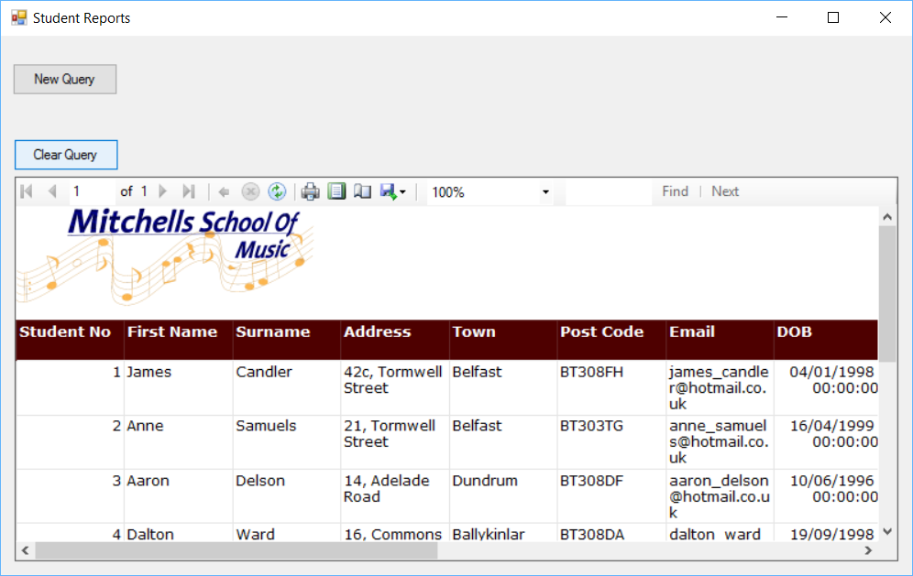

#### Querying the student report

1. Click the new query button.
2. Select the column to query.
3. Select the potential queries from the combo box below.
4. Click the add query button.

#### Clearing the query

1. Click the clear query button.

## Tutor reports

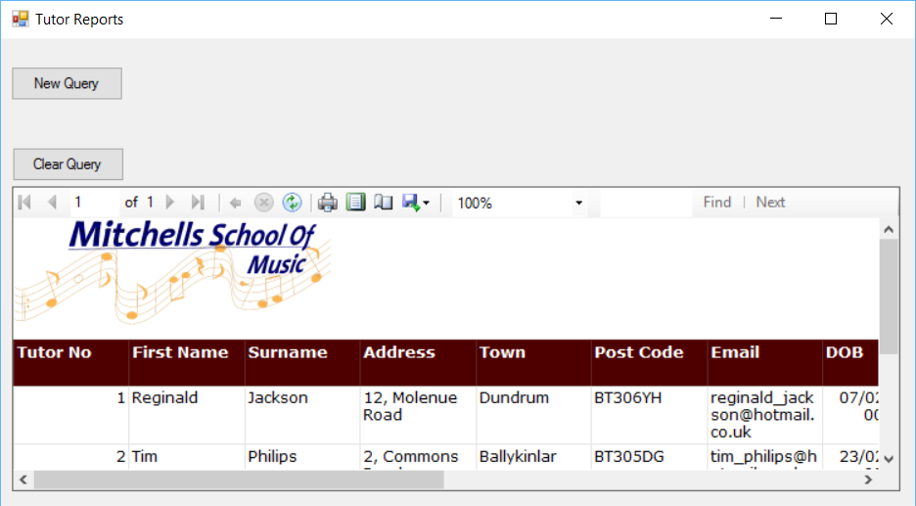

#### Querying the Tutor report

1. Click the new query button.
2. Select the column to query.
3. Select the potential queries from the combo box below.
4. Click the add query button.

#### Clearing the query

1. Click the clear query button.

## Booking reports

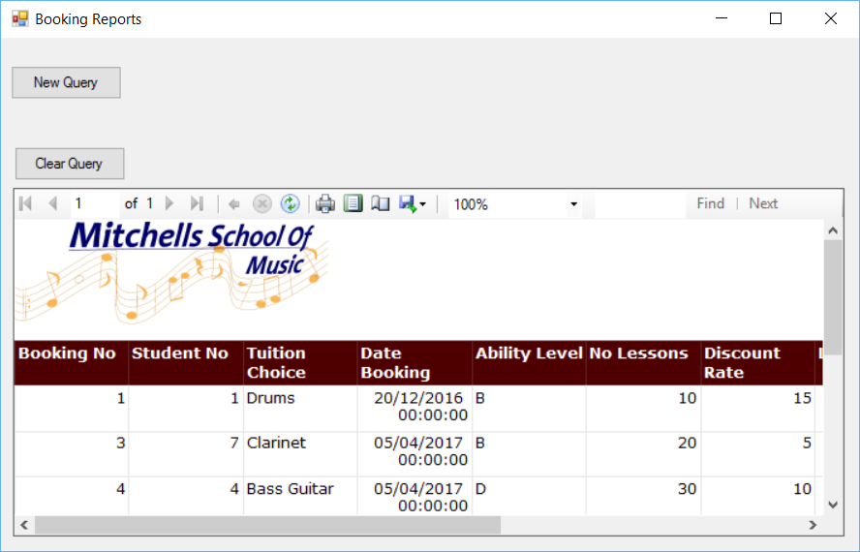

#### Querying the Booking report

1. Click the new query button.
2. Select the column to query.
3. Select the potential queries from the combo box below.
4. Click the add query button.

#### Clearing the query

1. Click the clear query button.

## Payment reports

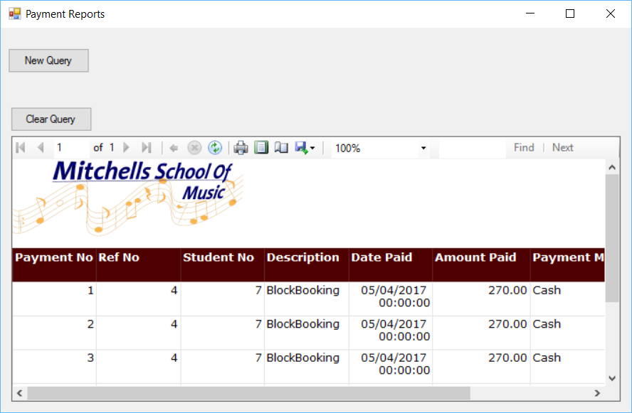

#### Querying the Payment report

1. Click the new query button.
2. Select the column to query.
3. Select the potential queries from the combo box below.
4. Click the add query button.

#### Clearing the query

1. Click the clear query button.

# Backup procedures

## Creating a backup of the SQL server

1. Open SQL server management studio



1. Connect to the server within which the database is located

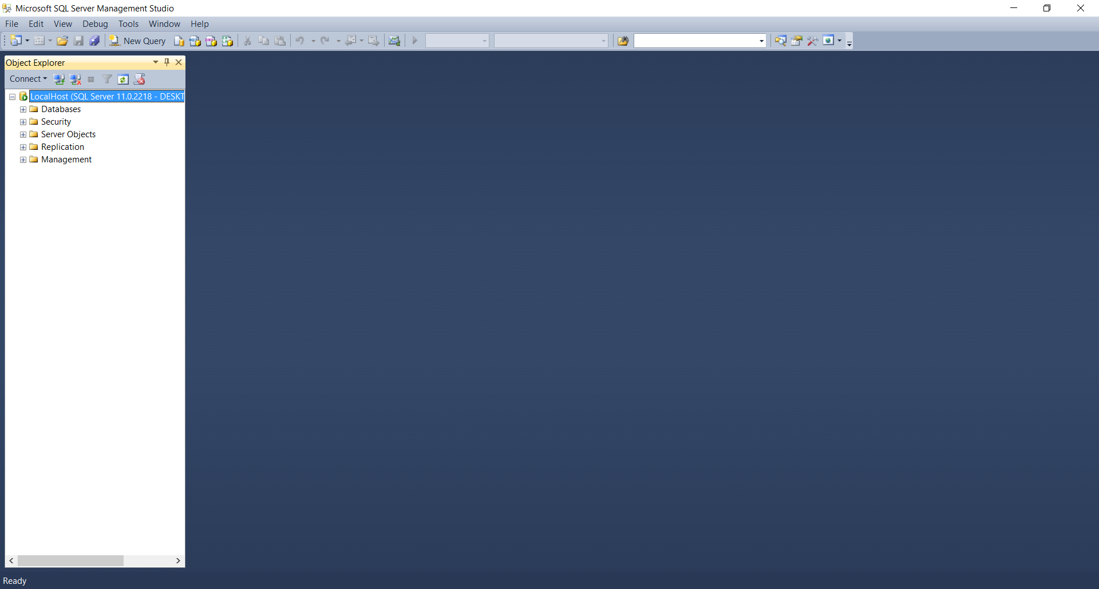

1. Right click the database within the object explorer typically located on the left side of the screen.
2. Hover over “tasks”
3. Select “backup…” from the menu that appears.

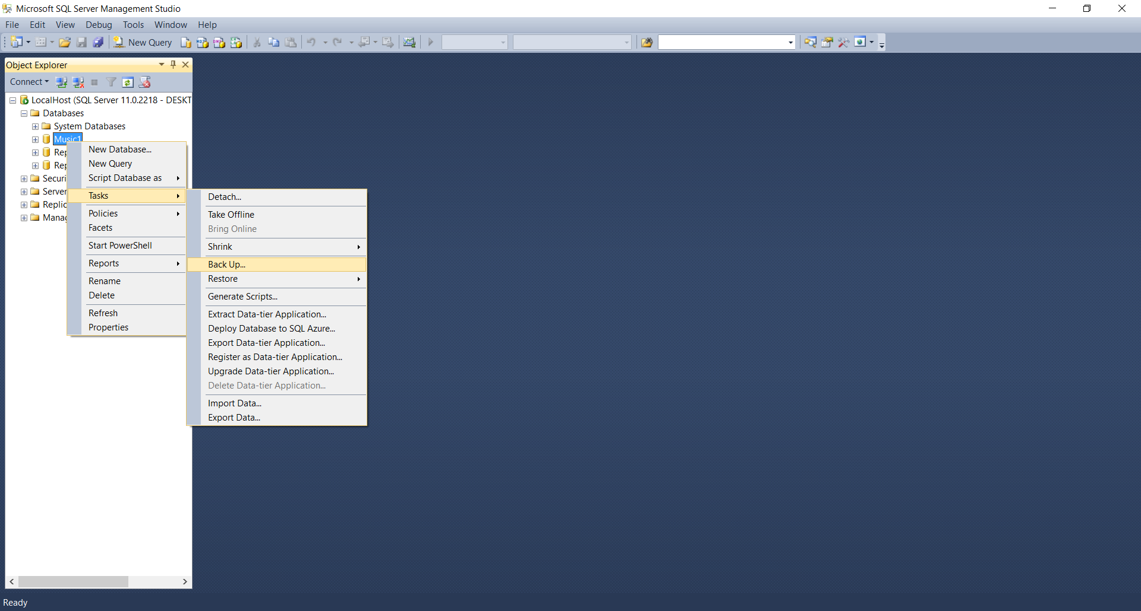

1. A menu will now appear with settings regarding how the database should be backed up. This area can be modified as needed.

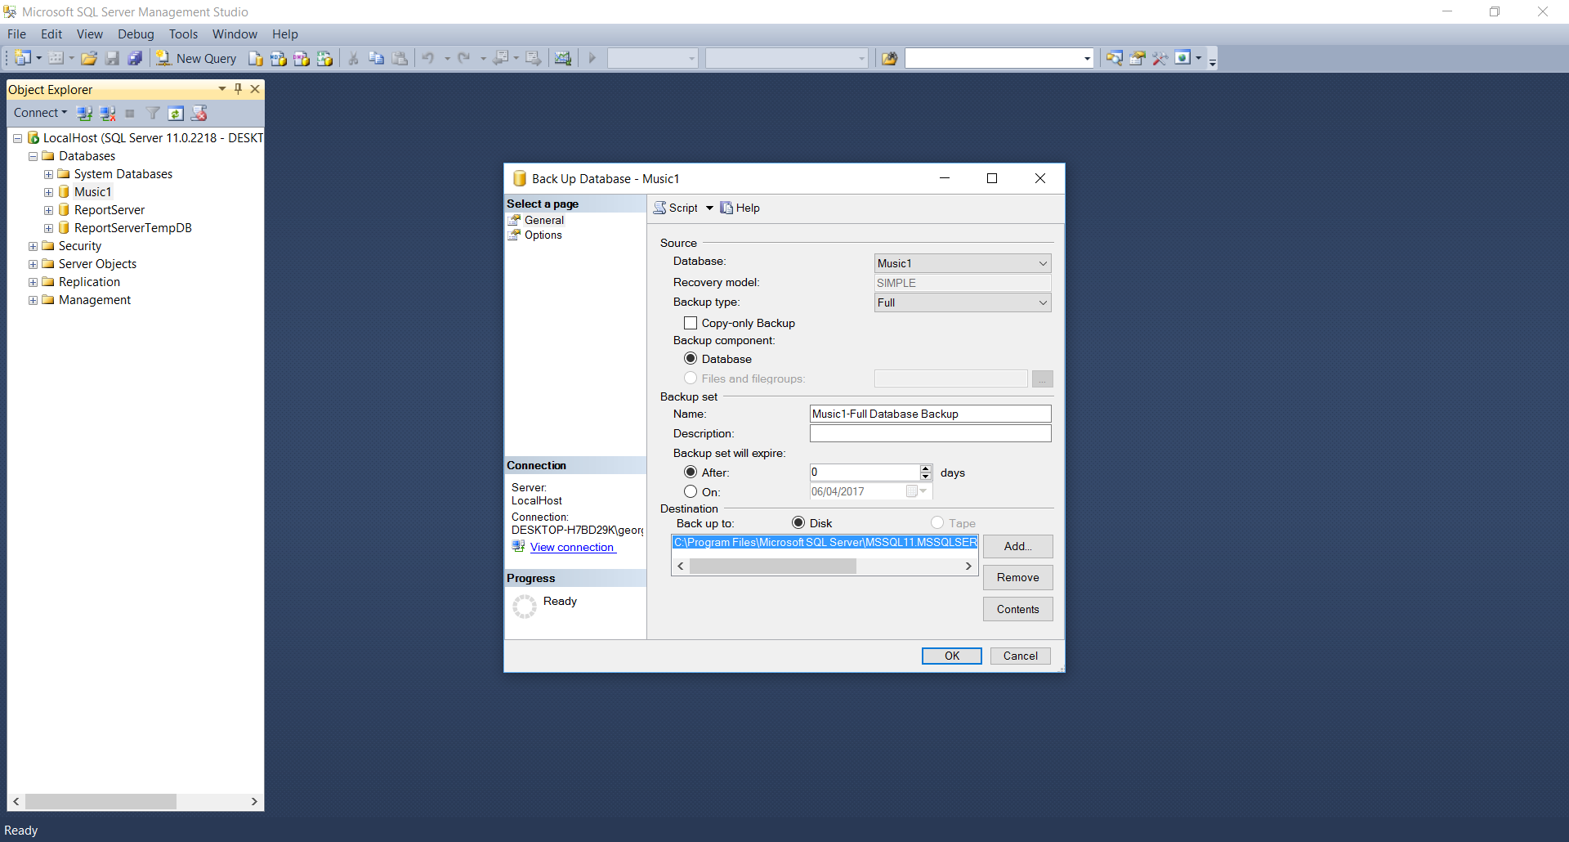

1. Click the “Ok” button at the bottom to begin backing up the database.

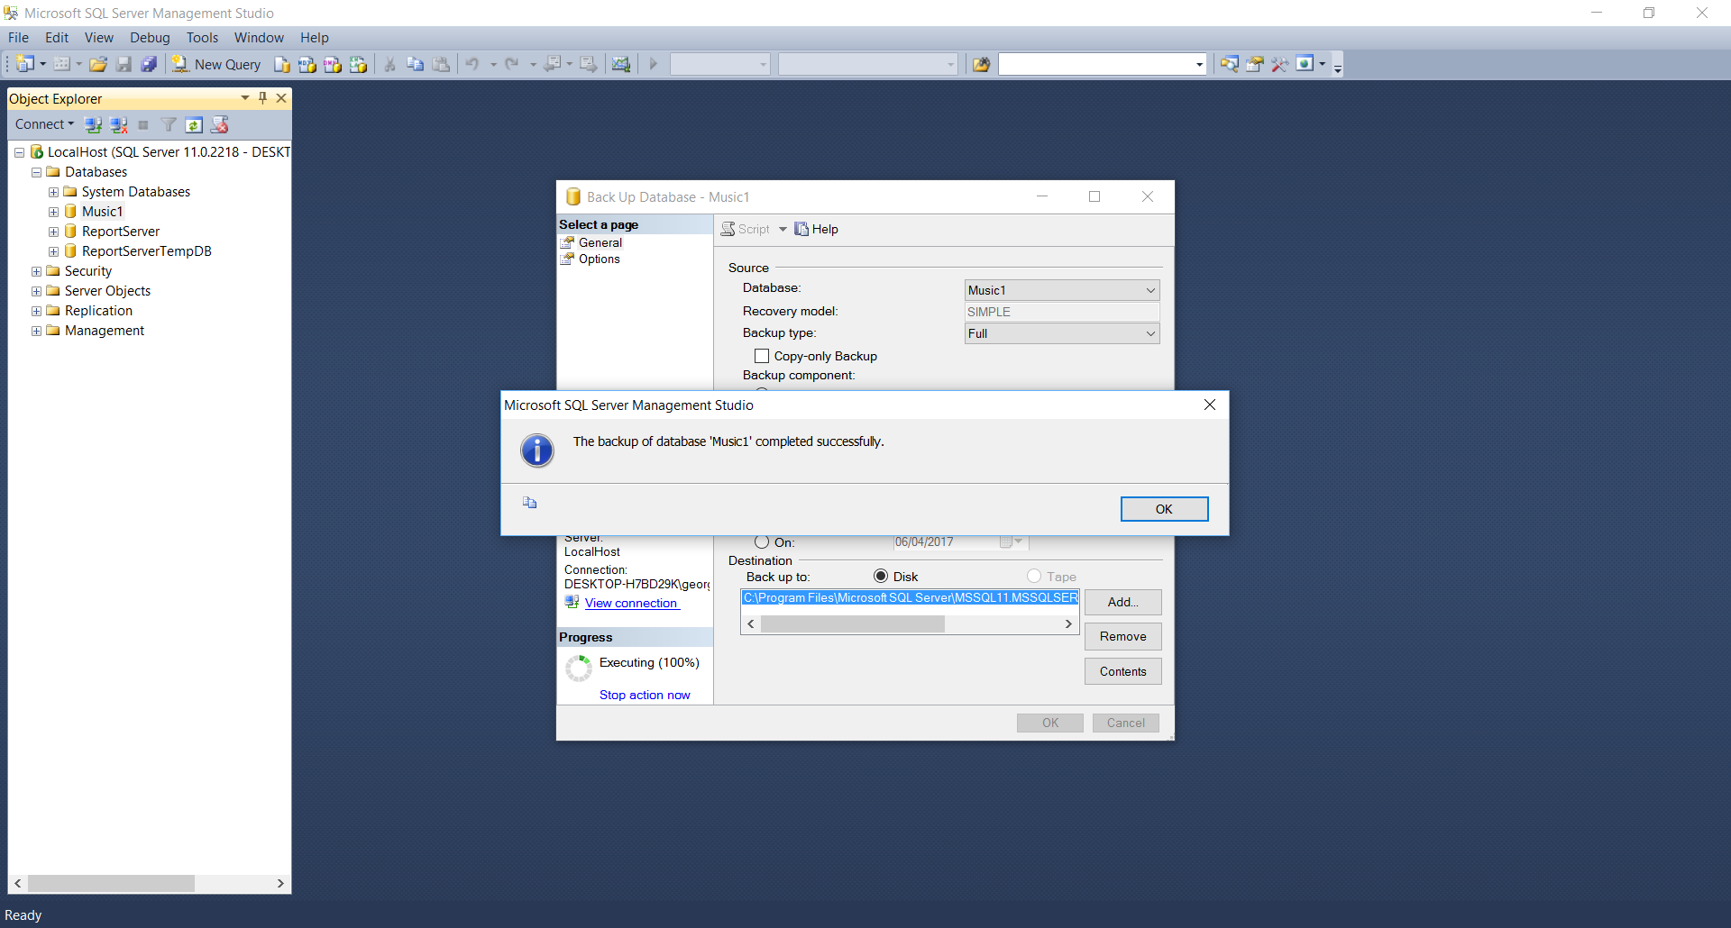

1. The database .BAK file should now be located within your devices files.

By default this will be: C:\Program Files\Microsoft SQL Server\MSSQL11.MSSQLSERVER\MSSQL\Backup

However, this is changeable within the backup settings.

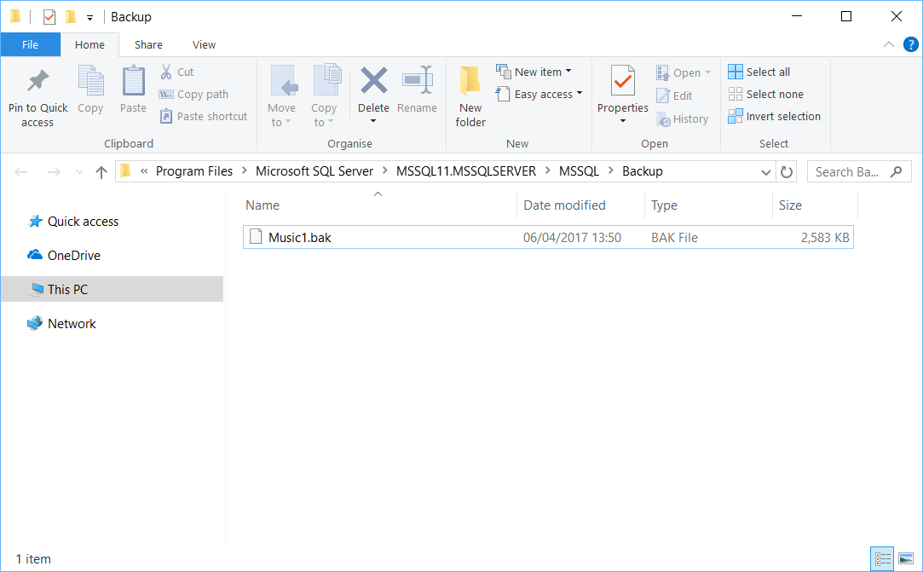

# Error handling

1. Error providers appear when fields are left blank or incorrect with corrective action.

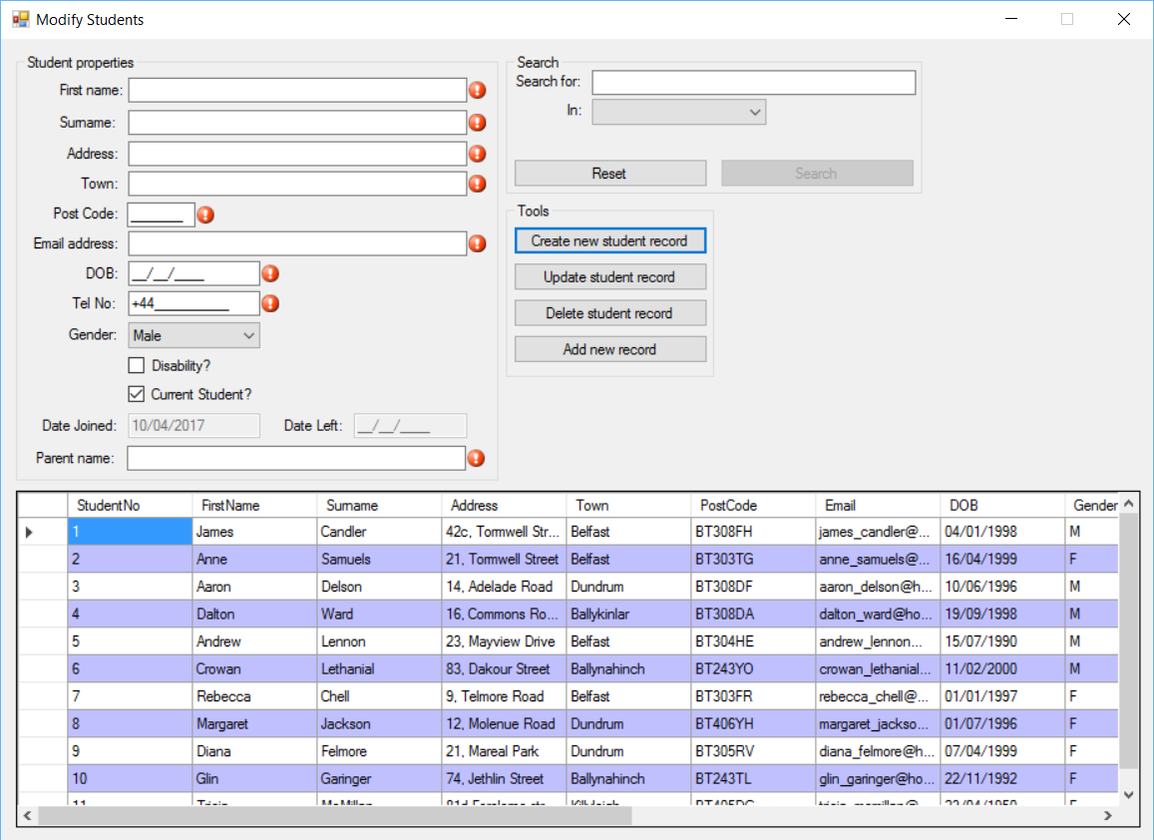

1. Unexpected errors are handled through the use of message boxes which appear with details about the exception.

# Further help and support

|  |  |
| --- | --- |
| Developed by | The Mitchell’s music school dev team |
| Contact support at: | mitchells_music_dev@hotmail.co.uk |
| Tech support No: | (+44)0284459361 |